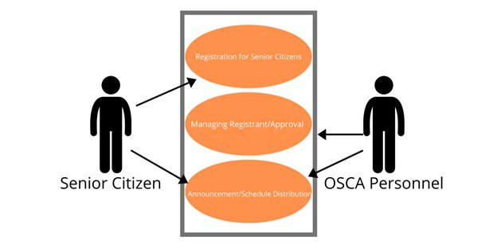

Use Case Diagram of the PenSys: Digitalized Informer and Registration System for Senior Citizen Pensioners

.

Shows the users of the PenSys: Digitalized Informer and Registration System for Senior Citizen Pensioners which are the Senior citizen and OSCA Personnel. The figure also shows the different processes that can only be accessed by specified users. Senior citizen can access the registration feature and can monitor the announcement feature of the system. OSCA personnel can manage the registrant and approval for the application for social pension. They can also make an announcement.

